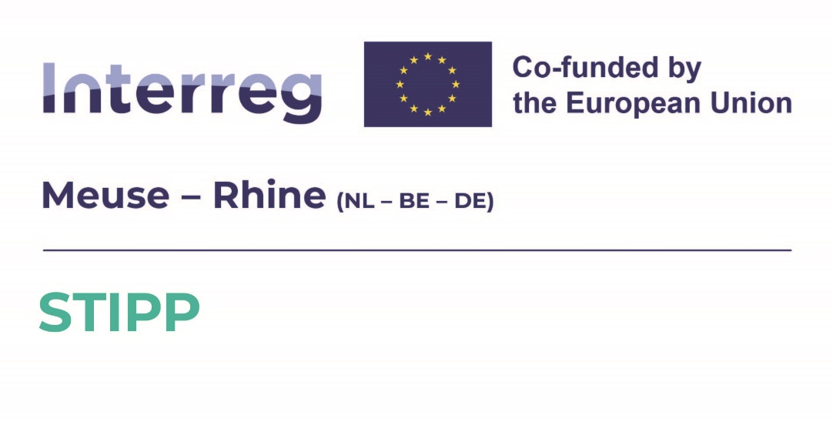

Detailed Subsidy Rules

for the Third STIPP SME Call for proposals under the

STIPP-initiative

under the cross-border
cooperation programme
Interreg Meuse-Rhine (NL-BE-DE)

PROVINCIAL BULLETIN

Official name of rules: Detailed subsidy rules for the Third STIPP SME Call for Proposals under the STIPP-initiative under the cross-border cooperation programme Interreg Meuse-Rhine (NL-BE-DE)

Title for citation: Detailed subsidy rules for the Third STIPP SME Call for Proposals Interreg Meuse-Rhine (NL-BE-DE)

Name of revoked rules: Not applicable

Resolved by: The Cluster Manager EMR in his capacity as fund manager STIPP

Topic: European (ERDF) grant for innovation projects of SME consortia in cross-border cooperation

Legal basis or Decision of the Ministry of Economic Affairs and Climate Policy of
capacity on which the 17 December 2022, no. WJZ/22253869, entailing delegation of the
rules are based: Managing Authority and the audit authority for the Interreg programme Meuse-Rhine (NL-BE-DE) 2021–2027;
Decision of the Managing Authority Meuse-Rhine (NL-BE-DE) 2021-2027 to the Province of Limburg on the project 'STIPP SME grant scheme'.

Effective date: 1 December 2025

Term rules are in force: 1 December 2025 to 31 March 2026

Responsible cluster: Cluster EMR

Introduction

The Cluster Manager EMR, following the proposal by the Board of Directors of the STIPP-initiative to support innovation projects of SME-consortia under the cross-border cooperation programme Interreg Meuse-Rhine (NL-BE-DE);

In consideration of the decision approving the programme by the European Commission of 14 November 2022, as well as in accordance with the decision of the Ministry of Economic Affairs and Climate Policy of 17 December 2022, no. WJZ/22253869, entailing delegation of the Managing Authority and the audit authority for the Interreg programme Meuse-Rhine (NL-BE-DE) 2021–2027.

In consideration of Regulation (EU) 2021/1060 of the European Parliament and of the Council of 24 June 2021 laying down common provisions on the European Regional Development Fund, the European Social Fund Plus, the Cohesion Fund, the Just Transition Fund and the European Maritime, Fisheries and Aquaculture Fund and financial rules for those and for the Asylum, Migration and Integration Fund, the Internal Security Fund and the Instrument for Financial Support for Border Management and Visa Policy;

In consideration of Regulation (EU) 2021/1058 of the European Parliament and of the Council of 24 June 2021 on the European Regional Development Fund and on the Cohesion Fund;

In consideration of Regulation (EU) 2021/1059 of the European Parliament and of the Council of 24 June 2021 on specific provisions for the “European territorial cooperation” goal (Interreg) supported by the European Regional Development Fund and external financing instruments;

In consideration of the agreements in the approved project applications and in the cooperation agreement regarding the governance, implementation, management and organisation of the STIPP-initiative including the establishment of the Board of Directors and establishment of procedural agreements regarding STIPP SME Calls for Proposals;

In consideration of the grant decision of the Executive Board of the Province of Limburg in its capacity as Managing Authority for the cross-border cooperation programme Interreg Meuse-Rhine (NL-BE-DE) on the project 'STIPP SME Grant Scheme ' by which the authority to adopt these Further Subsidy Rules has been assigned to the Cluster Manager EMR, in its capacity as fund manager of the Small Projects Fund STIPP SME Grant Scheme;

Whereas on 8 February 2023 the Monitoring Committee agreed to the general principles underlying these detailed subsidy rules, including the Cost catalogue Interreg Meuse-Rhine (NL-BE-DE) 2021–2027;
Whereas, on 2 August 2024, the Managing Authority issued a grant decision on the grant application seeking to establish and implement the Small Projects Funds STIPP SME Grant Scheme, as part of the STIPP Initiative;

Whereas, the aforementioned grant application, grant decision and cooperation agreement contain frameworks for the implementation of the STIPP SME Grant Scheme in the form of grants to SME consortia for innovation projects;

Whereas, the Board of Directors is responsible for the implementation of the STIPP-initiative and therefore for the openings of the Small Projects Funds STIPP SME Grant Scheme for applications from SME consortia;

Whereas the application form and the cooperation agreement define the procedure by which the Cluster Manager EMR, in his capacity as fund manager of the Small Projects Funds STIPP SME Grant Scheme, will structure the openings;

Whereas the eligible activities of SME innovation projects can be defined broadly, and this broad definition is intended to achieve optimal achievement of the objectives, the Fund Manager will review whether the total of government contributions to the subsidy recipient does not exceed the amount of state aid permitted under the provisions of European law. Specifically, for the purposes of the determination of whether state aid is justified, the Fund Manager considers the following regulations on state aid applicable:
- Regulation (EU) 651/2014 declaring certain categories of aid compatible with the internal market in application of Articles 107 and 108 of the Treaty, OJ L 187/1 of 26 June 2014, as last amended by Regulation (EU) 2021/1237 of 23 July 2021, OJ L 270/39 of 29 July 2021;
- Regulation (EU) 2023/2831 of 13 December 2023 on the application of Articles 107 and 108 of the Treaty on the Functioning of the European Union to the de minimis aid, OJ Series L of 15 December 2023.

Resolve on 25.11.2025 to establish the following subsidy rules:

DETAILED SUBSIDY RULES FOR THIRD STIPP SME CALL FOR PROPOSALS INTERREG MEUSE-RHINE (NL-BE-DE)

Chapter 1 General provisions

Article 1 Definitions

For the purposes of these rules, the following terms are defined as follows:

- General Block Exemption Regulation (GBER): Regulation (EU) 651/2014 declaring certain categories of aid compatible with the internal market in application of Articles 107 and 108 of the Treaty, OJ L 187/1 of 26 June 2014, as last amended by Commission Regulation (EU) 2023/1315 of 23 June 2021, OJ L 167/1 of 30 June 30 2023;
- Audit Authority: The director of the “Auditdienst Rijk” of the Netherlands is designated as the Audit Authority, as referred to in Article 45, paragraph 1, of Regulation (EU) 2021/1059, for the Interreg Meuse-Rhine programme and as referred to in Article 2, paragraph 2 of the decision of the Ministry of Economic Affairs and Climate Policy of 17 December 2022, no. WJZ/22253869, entailing delegation of the Managing Authority and the Audit Authority for the Interreg Meuse-Rhine (NL-BE-DE) programme.
- Managing Authority: Provincial Executive of the Province of Limburg is designated as Managing Authority (as referred to in Article 45, paragraph 1, of Regulation (EU) 2021/1059 for the Interreg Meuse-Rhine programme and as referred to in Article 2, paragraph 1 of the decision of the Ministry of Economic Affairs and Climate Policy of 17 December 2022, no. WJZ/22253869, entailing delegation of the Managing Authority and the Audit Authority for the Interreg Meuse-Rhine (NL-BE-DE) 2021-2027 programme.
- Board of Directors: the entity consisting of directors/representatives of the Regional Development Agencies involved and the Fund Manager, which provides guidance and direction on the STIPP-initiative;
- De minimis aid: aid that meets the conditions for exemption from registration as set out in Regulation (EU) 2023/2831 of 13 December 2023 on the application of Articles 107 and 108 of the Treaty on the Functioning of the European Union to the de minimis aid, Pb EU Series of 15 December 2023, including any amendments thereto to be adopted in the future.
- Expert Committee: the group of experts, as assembled by the Board of Directors in accordance with the selection procedure, which issues advice on submitted eligible applications;
- ERDF: European Regional Development Fund.
- Final beneficiary: the beneficiary of grant that is transferred to him from this grant scheme;
- Small Projects Fund : a project consisting of the creation of a fund in accordance with the provisions of Article 25 of Regulation (EU) 2021/1059 on specific provisions for the European Territorial Cooperation Objective (Interreg) supported by the European Regional Development Fund and by external financial instruments;
- Fund Manager: the Cluster Manager EMR;
- Fund Management: the team that supports the Fund Manager in his tasks;
- Manual: the document containing descriptions and explanations of this Scheme and the implementation of projects under this Scheme;
- Innovation region: the individual regions of South Netherlands, Flanders, Wallonia (including Ostbelgien) and North Rhine-Westphalia (including Rhineland- Palatinate);
- Cost catalogue: catalogue with further details of eligible and ineligible costs for the cooperation programme drafted on the basis of Article 37, paragraph 2, of
Regulation (EU) 2021/1059 and approved by the Monitoring Committee on 8 February 2023 and published on the website of the cooperation programme (http://www.interregmeuserhine.eu).
- Lead partner: a public or private legal entity that acts as a grant applicant on behalf of a partnership;
- SME consortium: a partnership based on a cooperation agreement consisting of at least two mutually independent SMEs from at least two different Member States belonging to the program area;
- SME: small and medium-sized enterprise as defined in Annex 1 of the General Block Exemption Regulation;
- Monitoring Committee: the committee charged with the monitoring of the performance of the cooperation programme in accordance with Article 28, 29 and 30 of Regulation (EU) 2021/1059.
- Enterprise: unit that engages in an economic activity, irrespective of its legal form and the manner in which it is financed.
- Undertaking in difficulty: a company falling under the provisions of Article 2, definition 18 of the General Block Exemption Regulation;
- Output and result indicators: indicators as referred to in Article 16, paragraph 1 under (a) and Article 22, paragraph 3 under (d. ii and e. ii ) of Regulation (EU) 2021/1060, and the Commission staff working document on Performance, monitoring and evaluation of the European Regional Development Fund, the Cohesion Fund and the Just Transition Fund in 2021-2027, and as elaborated in chapter 2 of the cooperation programme document.
- Programme area: territory of the Meuse-Rhine area, as defined in chapter 1.1 of the Interreg Meuse-Rhine (NL-BE-DE) programme document.
- Operation of Strategic Importance (OSI): a project that meets one or more of the three points as listed in Annex 3a of the programme document of the Interreg Meuse-Rhine Cooperation Programme (NL-BE-DE);

- Cooperation programme: Interreg Meuse-Rhine (NL-BE-DE) programme; programme as referred to in Article 3, paragraph 1 (a), of Regulation (EU) 2021/1059, approved by the European Commission on 14 November 2022 (2021TC16RFCB001); this programme can be consulted on the website http://www.interregmeuserhine.eu;
- State aid: any aid granted as referred to in Article 107(1) of the Treaty on the Functioning of the European Union

Article 2 Objective of the rules

The rules make subsidy available for projects from SME consortia that contribute to market-oriented innovative solutions to the major challenges as described and incorporated into the Cooperation Programme:
- industrial transition,
- green transformation,
- healthier inhabitants.

Article 3 Applicant and beneficiary

- Subsidy under these rules can be applied for by an SME acting as a lead partner of a partnership referred to in Article 13, paragraph 1, subparagraphs 4 and 5.
- The partnership shall meet the following requirements:

  - the partnership consists of a minimum of two mutually independent SMEs;
  - the participants are located in at least two Member States in the programme area;
  - none of the partners qualifies as undertaking in financial difficulty.
- The partnership can include SMEs not located in the programme area. The share of these partners in the requested grant can be up to 10%.
- The partnership may include partners that do not qualify as SMEs, however, these partners do not qualify for funding.
- A private legal entity in the partnership can be the beneficiary of the subsidy.

Article 4 Obligations of subsidy recipient

The granting of a subsidy is subject to the following obligations:
- The recipient of the subsidy performs the project in accordance with the project plan on which the subsidy was granted, begins no earlier than the date he submits his application and completes it no later than the moment specified within the subsidy grant.
- The subsidy recipient will report to the Fund Manager prior to the change of a project for which subsidy is granted, any proposed change pertaining to
- the subsidy recipient;
- the activity to be performed or the objectives to be achieved;
- the budgeted cost of the project (by partner);
- the funding of the project (by partner);
- the planning or duration, and/or:
- other changes compared to the project plan.
Where specified in the Manual, these changes require the approval of the Fund Manager.
- Alongside the provisions of paragraph 2, the subsidy recipient will immediately notify the Fund Manager in writing at the moment that it becomes likely that the obligations imposed under the decision for the granting of the subsidy will not be met, or will not be met in a timely manner and/or in full.
- The subsidy recipient keeps records that are set up in such a way that all costs incurred and paid can be specified and checked at all times in a simple and clear manner in accordance with terms and conditions as stated in the Cost catalogue Interreg Meuse-Rhine (NL-BE-DE) 2021-2027.
- The subsidy recipient is obliged to cooperate with all audits considered necessary for the performance of the programme.
- The Fund Manager may also impose other obligations on the subsidy, including reporting requirements on the material and financial progress.

Article 5 Grounds for rejection

- An application may be rejected if:
- The project does not contribute to the specific objectives of this call within the STIPP initiative as described in Article 2.
- It is not submitted by an applicant as defined in the first paragraph of article 3 and/or does not benefit the beneficiary as defined in the second paragraph of article 3.
- It fails to comply with the provisions of chapters 4 and 5 of this document.
- The subsidy application is not fully received or received outside the period given in article 12.
- The subsidy application pertains to activities aimed at the regular operations of an enterprise or institution.
- The project does not fulfil the European regulations on issues such as state aid and/or public procurement.
- The total eligible cost of the project amounts to less than € 150.000.
- The share of the applicant or one of the beneficiaries in the total project cost is 70% or more;
- The applicant or one of the beneficiaries is an enterprise against which there is an outstanding recovery order as defined in paragraph 4(a) of Article 1 of Regulation (EU) 651/2014 of 17 June 2014, by which certain categories of aid are, under Articles 107 and 108 of the Treaty, considered to be compatible with the internal market (OJ L 2014, 187).
- An enterprise involved as an applicant or beneficiary can be considered to be in difficulty as defined in part (c) of the fourth paragraph of Article 1 of the General Block Exemption (Regulation (EU) 651/2014).
- Without prejudice to the provisions of the first paragraph, the Fund Manager may decide to reject some or all of an application if it is clear that any or all of the intended financing will not be granted by the other co-financing parties.

Chapter 2 Content aspects regarding the Third STIPP SME Call for proposals

Article 6 Specific objectives

- The specific project call is opened for projects that fit within the following priority and specific objective (SO):

Priority | Specific objective
1. A smarter Meuse-Rhine area | SO 1.iii Enhancing sustainable growth and competitiveness of SMEs and job creation in SMEs, including by productive investments.

- In further detail, this call for projects is opened to projects that address the priority and specific objective (SO) mentioned in paragraph 1 through direct and market-oriented collaboration in SMEs in the field of innovation and contribute to innovative solutions to the grand challenges that are at the core of the cooperation programme:
a. industrial transition,
b. green transformation,
c. healthy inhabitants.

Chapter 3 Financial aspects Third STIPP SME Call for proposals

Article 7 Subsidy ceiling

- The Board of Directors has set the subsidy ceiling for this particular call for projects in terms of available ERDF funds at EUR 3.000.000.
- In case there are more projects of good quality than the subsidy ceiling, the Board of Directors can decide to increase the subsidy ceiling within a flexibility margin of up to 20 percent.

Article 8 Amount of subsidy

- The amount of the ERDF subsidy is maximum 50% of the project’s total eligible costs, taking into account detailed maximums as listed in annex 1.
- If the applicant applies for less than 50% of the eligible costs as referred to in the first paragraph, then only the subsidy percentage applied for will be granted.
- Where there is state aid and the activity meets one of the conditions of the second paragraph of Article 10, the amount of subsidy granted will only be such that the total of government contributions to the subsidy recipient does not exceed than is permitted under European state aid law under Article 20 of the General Block Exemption Regulation.

Article 9 Eligible and ineligible costs

- As to the calculation bases of eligible costs, the rules and conditions regarding cost options as laid down in the Cost Catalogue Interreg Meuse-Rhine (NL-BE-DE) 2021-2027 apply, with the exception of the cost option 'lump sums'.
- Eligible and ineligible costs are governed by the rules and conditions as set out in the Cost catalogue Interreg Meuse-Rhine (NL-BE-DE) 2021-2027.
- In case of state aid granted under application of the General Block Exemption Regulation, then only the costs identified in the applicable article 20 of the General Block Exemption Regulation are eligible for expenditure.

Chapter 4 General information application

Article 10 General criteria

1. The general criteria for the subsidy are as follows:
- The project has a maximum duration of two years (24 months);
- The start date for implementation of eligible activities under the project is no earlier than the date the application is submitted;
2. In case of state aid, in order to be eligible for subsidy the project must:
- fit within article 20 of the General Block Exemption Regulation,
- meet the conditions of the relevant article, and
- comply with the general and procedural provisions in Chapter I and II of the relevant Regulation.
Chapter 5 Application procedure, planning, assessment criteria, quality assessment, decision and decision period

Article 11 Submission of the application

- A subsidy application:
- must be submitted to the Fund Manager;
- can only be submitted through the electronic system JEMS-STIPP;
- comprises at least:
    - the fully completed application form in the electronic system JEMS-STIPP;
    - a partnership agreement signed by all participants in the partnership;
    - evidence of any co-financing that is not one's own organisation's contribution, or the intention to make it available;
    - of all members of the partnership individually a prescribed self-declaration on the legal (SME) status which also shows that in the partnership there is no outstanding recovery nor undertaking(s) in difficulty as referred to in Article 1(4)(c) of the General Block Exemption Regulation.

Article 12 Period for submission of the application

The subsidy application can be submitted as of 1 December 2025 at 16:00 hours and has to be received by the Fund Manager no later than 31 March 2026, 12:00 hours (noon).

For the date of receipt, the date of receipt of a complete subsidy application in the JEMS-STIPP system is decisive.

In the event that the electronic JEMS-STIPP system is not accessible, the submission period may be extended if the cause of the inaccessibility is connected with server problems on the Managing Authority’s server. This is subject to the following provisions:

In the event of inaccessibility on 24 March 2026, 9:00 AM to 27 March 2026, 9:00 AM, an extension will only be applied if the system is inaccessible for more than 8 uninterrupted hours.

In the event of inaccessibility on 27 March 2026, 9:00 AM to 30 March 2026, 18:00 hours, an extension will only be applied if the system is inaccessible for more than 2 uninterrupted hours.

In the event of inaccessibility on 30 March 2026, 18:00 hours to 31 March 2026, 12:00 (noon), an extension will only be applied if the system is inaccessible for more than 30 minutes.

The duration of an extension will in all cases be equal to the duration of the interruption.

Article 13 Assessment criteria

In the assessment process, a distinction is made between assessing the grant eligibility requirements and assessing the selection criteria.

13.1 Grant eligibility requirements

- The grant eligibility requirements will be administratively checked by the Fund Management:

 | Requirements
1 | The application has been submitted within the defined call for proposals period in JEMS-STIPP.
2 | The application has been formulated in English.
3 | All mandatory fields for the application in JEMS-STIPP have been properly filled in.
4 | The project involves at least two SMEs from two Member States within the programme area.
5 | All partners (lead partner and other partners in the partnership) are a legal body.
6 | All applicants in the partnership qualify as SMEs.
7 | None of the applicants in the partnership qualify as undertaking in difficulty.
8 | The project does not start before the application submission date, has a maximum duration of 24 months and does not end after 30 September 2029.
9 | The Cost Catalogue has been handled correctly.
10 | The maximum ERDF co-financing rate as stated in the text of the call for proposals has not been exceeded.
11 | Funding of eligible costs meets the requirement of at least 50% private (own) contribution.
12 | The same or similar project cannot apply for funding from another Interreg programme at the same time.

- The Board of Directors, having heard the advice from the Expert Committee, assesses applications against the following eligibility requirement:

 | Requirement
13 | The activities in the project qualify at TRL stages 4 to 9.

- If an application does not meet all of the above eligibility requirements, that application will not be assessed against the selection criteria.

13.2 Selection criteria
The selection criteria are listed below. Applications are assessed accordingly by the Board of Directors, having heard advice from the Expert Committee

Selection criterion | Weight
1: Degree of innovativeness | 15%
2: Degree of focus on the social challenges of the Cooperation Program | 15%
3: The degree of cross-border cooperation and added value | 15%
4: The potential degree of economic impact | 25%
5: The quality of the partnership | 15%
6: The quality of the application | 15%

13.3 Quality assessment on the grant application
- The degree to which applications meet each selection criterion, including the sub-aspects included, will be evaluated based on the score table below:

Quality assessment | Score
Outstanding | 5
Good | 4
Adequate | 3
Weak | 2
Insufficient | 1

- The quality assessment goes as follows:
- Every applicable selection criterion will be awarded a single score.
- The points per selection criterion are totaled and weighted in order to arrive at a total score.
- An application has to score at least 3 points (unweighted) per applicable selection criterion, and thus also 3 points overall (weighted).

Article 14 Distribution of subsidy ceiling and decision

- The Board of Directors sets a score for each project on the selection criteria and thus the overall score.
2. The Board of Directors ranks each project that meets the requirement as mentioned in Article 13(2) based on its score (from high to low).
3. The ranking of projects selected by the Board of Directors is then submitted to the Fund Manager, who then proceeds to final technical checks and formal decision-making.
4. The distribution of the subsidy ceiling will be made among the subsidy applications that sufficiently meet the selection criteria as stated in Article 13 and that have passed the final technical checks by the Fund Manager.
5. For applications that meet all the requirements and conditions listed in paragraph 4, the Fund Manager will make a decision to award a subsidy based on the ranking, taking into account the available ERDF budget per opening as shown in Article 7.
6. Applications that do not meet the minimum score requirements on the selection criteria, or that fall outside the subsidy ceiling based on their place in the ranking, will be rejected.
7. Notwithstanding the above provisions, the Fund Manager may decide to reject an application in whole or in part if it does not comply with the rules of the Cooperation Programme or with the rules with which the Cooperation Programme must comply.

Article 15 Decision period

The Fund Manager will make a decision on an application no later than 14 weeks after the application deadline closes.

Chapter 6 Implementation and subsidy determination

Article 16 Payment and advances

- The Fund Manager may make an advance payment on a request made by a Beneficiary for this purpose subject to the following provisions:
a. A request shall be made upon application for the subsidy or upon the grant of the subsidy,
b. An advance payment under this paragraph shall not exceed 40% of the granted subsidy,
c. Advance payments under this paragraph are not based on a progress report. Interim payments based on the second paragraph are supplementary to an advance payment based on this paragraph, whereby the maximum percentage of 90% from the second paragraph applies to all payments together.

- Based on a progress report submitted by beneficiaries for this purpose, the Fund Manager shall provide interim payments of the granted subsidy amount up to 90% of the granted subsidy. Interim payments under this paragraph amount to the granted subsidy percentage in the eligible costs in the payment application. The abovementioned maximum percentage of 90% applies to all interim payments together, including any advance payment provided under paragraph 1.
- Beneficiaries must submit a progress report twice per year.
- A progress report consists of a content part and a financial part (payment application). The content part has to contain the content progress of the project, including the realisation of the deliverables and the output and result indicators as mentioned in the application form. The payment application must include at least the declaration of eligible costs incurred and any ineligible costs.
- Payment to beneficiaries will take place in accordance with Article 74, paragraph 1 (b), of Regulation (EU) 2021/1060, which means that the payment to the beneficiary has to be made no later than 80 days after the submission of the progress report.

Article 17 Subsidy determination

- Within the time period specified in the grant letter, the beneficiary must submit an application for the determination of the subsidy to the Fund Manager, via the JEMS-STIPP system, using the form specified for that purpose by the Fund Manager.
- In the application referred to in the first paragraph, the beneficiary must demonstrate that:
- the activities for which the subsidy has been granted have been performed.
- the obligations in connection with the subsidy have been met.
- The following supplementary documentation must be attached to the determination of the subsidy as referred to in the first paragraph:
- a substantive final report;
- documentation substantiating the reported value(s) for the output and result indicators;
- a financial report.
- The Fund Manager will make a decision on an application for determination of the subsidy within 14 weeks.
- After the determination of the subsidy, the final payment of the subsidy is made.

Chapter 7 Final provisions

Article 18 Effective date

- This decision goes into effect on 1 December 2025.
- These rules expire as of 31 March 2026, provided that they continue to apply to subsidy applications received prior to that date by the Fund Manager and subsidy decisions made prior to that date, including subsequent steps in the subsidy process.
- These rules can be cited as “Detailed Subsidy Rules for the Third STIPP SME Call for Proposals Interreg Meuse-Rhine (NL-BE-DE)”.

Annex 1 Detailed maximum subsidy amounts related to Article 8(1)
For projects, the maximum obtainable subsidy amounts are related to the composition of the partnership. This involves detailed examination of the origin (location) of the participants, ordered by the different “levels” at which the programme area can be considered geographically and policy-wise.
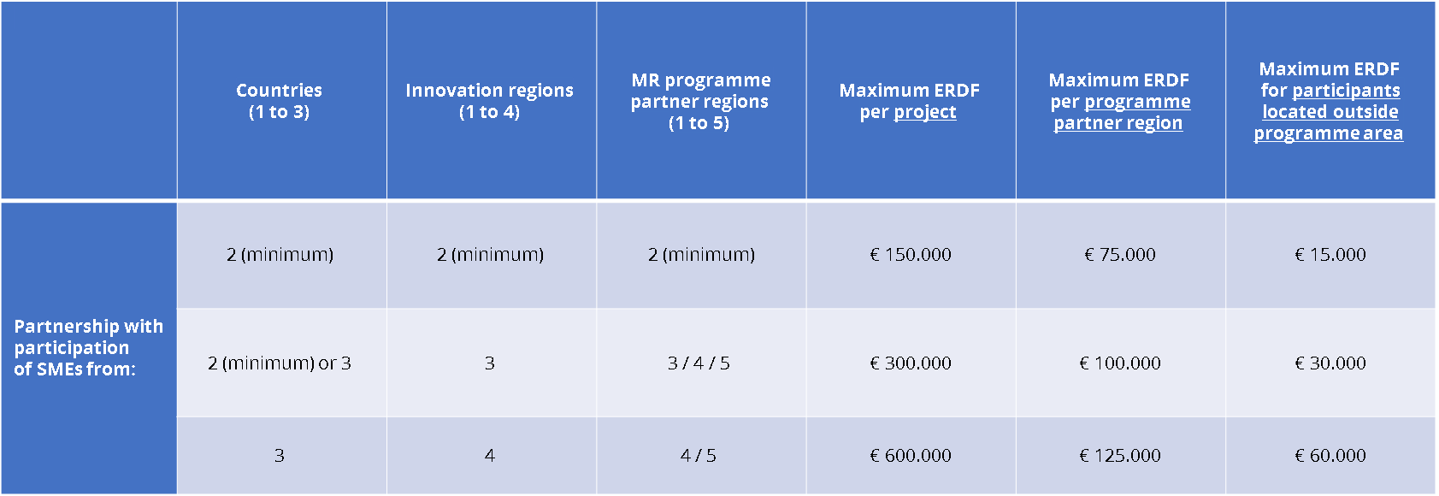
The abovementioned “levels” can be explained as follows:

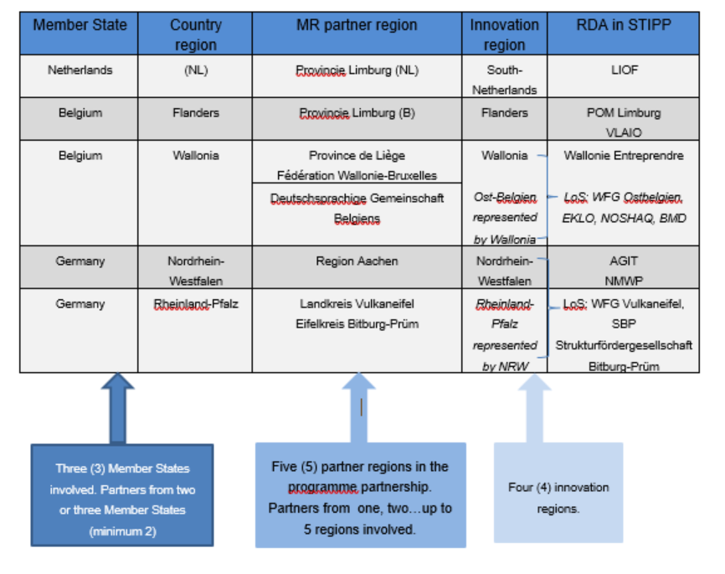

This is the English translation of the Detailed Subsidy Rules for the Third STIPP SME Call for Proposals under the STIPP-initiative for Interreg Meuse-Rhine (NL-BE-DE), first published in the Dutch language on 1 December 2025 in the Provincial Bulletin (Provinciaal Blad), going into effect on 1 December 2025. In case of differences in interpretation, the published text in the Dutch language will prevail.

